PO Box 488 Merville BC V0R 2M0, tsolumriver@shaw.ca, 250 897-4670
Tsolum River Fact Sheets
LOW FLOWS

Objective: To increase coho and trout rearing habitat

The Tsolum River is host to three species that require wetted fresh water habitat for a full year or more. Coho, rainbow trout and cutthroat trout require at least one full year of growth before they head to the ocean. Coho for four or five years to become 8 – 20 lb fish, rainbow to become the mighty steelhead and cutthroat to become the West Coast Sea-Run Cutthroat both of which return to spawn in a short two years and come and go to the ocean many times before leaving their bodies to the environment. Coho like most salmon spawn once and die as fertilizer for the river. The nutrient-rich decay feeds, the river, land and forest. A myriad of microorganisms, insects, animals and plants receive nutrition so that each can then go on to do the work each of them do to keep the ecosystem sustainable. The interdependence is profound.

Spawning coho adults begin entering the Tsolum River with early October rains and have finished the spawning process by about Christmas. While they are entering to create the next generation, the eggs that were spawned the previous year are now fry (baby salmon about 3 – 4 inches in length).

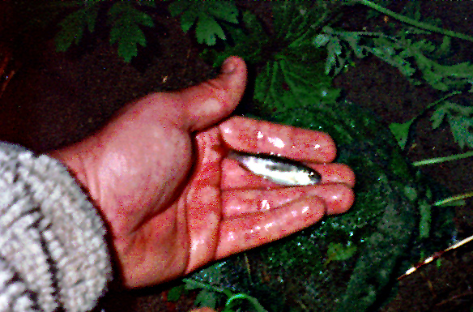
These baby coho from the past year find places to hide while the next generation is being spawned.

The newly spawned eggs immediately begin the process of becoming fish and the cycle starts all over again. Simply put, there are coho and trout in various stages of their lives in the river 12 months of every year to complete the cycle!

To do this they need water in quantities that provide the rearing time needed and of such quality that it supports the array of living creatures that support salmon and trout.

Low late summer flows dry up the habitat, making it so shallow and still that it warms in the sun beyond the tolerance of the stressed out little fish and up to 100% of the next generation can be lost. We must retain water from the excessive winter flows to provide water for these extreme low flow events.

How are going to do this?
We have completed a study and are working with all watershed partners to slow down run off, store winter water and use this to augment low summer flows. We currently use Wolf Lake as a storage facility and begin releasing water to assist pink salmon enter the river in August.

Complete a full riparian assessment to determine priority replanting for water retention, cooling and insect production.

We have developed some rearing habitat utilizing ponds that collect and store water for the summer and will build and restore much more over time.

We are mounting a fry salvage program for landowners, residents and volunteers. We will provide training and equipment so stranded and dying coho and trout can be moved to safety.

Work with the agricultural community to help find storage opportunities to accomplish slower release from field drainage systems. This will encourage aquifer recharge and the storage of irrigation water for use instead of wells or rivers.

Develop more project ideas that slow run off and accomplish storage with private managed forest companies.

Restore channel conditions throughout the watershed by deepening and narrowing channels and restoring pool-riffle complexing.

Encourage domestic rainharvesting, rain barrels, “purple pipe” water re-use, cisterns and hydrating cisterns to make “rainwater management” a household word as we take care of the animals and plants that need river flow.

Public Education and school programs to share the information that water is finite, freshwater is rare and we have excess in winter and not nearly enough in the summer and early fall

